CET Pronunciation Workshop
English Pronunciation: From the Ground Up
Karen Chung 史嘉琳
台大外文系 副教授
English questions answered free on: Karen on Ivy League Analytical English on
https://www.facebook.com/Karen-on-Ivy-League-Analytical-English-234235001756/timeline/
Series of articles in Chinese on English learning and pronunciation
in CET Cave's English Teaching bimonthly magazine: HellO! E.T.: First link
Online Phonetics Course 語音學on NTU Open Course Ware 台大開放式課程page:
http://ocw.aca.ntu.edu.tw/ntu-ocw/index.php/ocw/cou/101S102
Subscribe to Email updates: http://eepurl.com/505qT

- Fun with vowels: Apples and Bananas, by Raffi
https://www.youtube.com/watch?v=oacQL7UQtlk
- I like to eat, eat, eat apples and bananas;
I like to eat, eat, eat apples and bananas.
- I like to ate, ate, ate aypples and benaynays;
I like to ate, ate, ate aypples and benaynays.
- I like to eat, eat, eat eepples and beeneenees;
I like to eat, eat, eat eepples and beeneenees.
- And I like to ite, ite, ite eipples and bineineis;
I like to ite, ite, ite eipples and bineineis.
- I like to ote, ote, ote, oaplles and bononos;
I like to ote, ote, ote, oaplles and bononos.
- And I like to ute, ute, ute oopples and bunoonoos;
I like to ute, ute, ute oopples and bunoonoos.

- How you sound to others before working hard on your pronunciation:
https://www.youtube.com/watch?v=w8MlL2GhhOw&t=43s

Poor pronunciation…
• affects understanding
• makes other people tired as they struggle to understand you
• makes others think you are less intelligent than you are
• will affect your social life
What can happen if you're sloppy about your vowels:
你有沒有不小心講出「限制級英文」? http://www.eisland.com.tw/Main.php?stat=a_0GECDzr&mid=36
- Priorities, commitment, new HABIT formation
One Small Step Can Change Your Life animated by Nathan Lozeron
Also: How to Build Habits & Execute Effortlessly https://www.youtube.com/watch?v=w8MlL2GhhOw
https://www.youtube.com/watch?v=-LdhudFvJuE 1-page pdf
Ask yourself:  - Do I really want to improve my English?  - How high a priority is it for me?  - If it is a high priority, then I will find a time  to work on my English DAILY.  Take baby steps! But do it EVERY DAY!  Make it AUTOMATIC! | 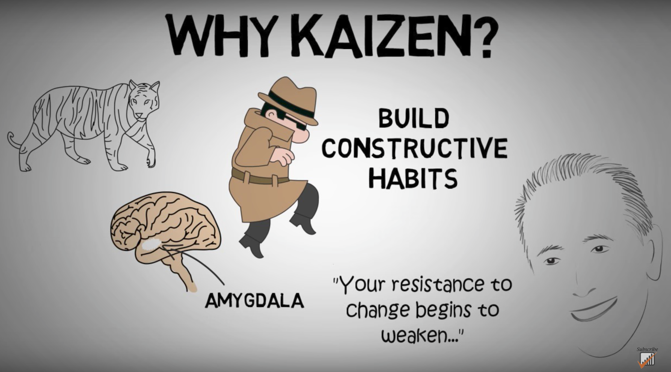  https://www.youtube.com/watch?v=VHkOFs67d9A
When, where, what?
- I will work on my English for 10-15 minutes starting from _____:_____ am / pm EVERY DAY.
- I will work on my English here: ___________________________.
- I will practice with these materials: __________________________________.
(TV show/movie/podcast/audio file)

Don’t beat yourself up if you miss a day, but DON’T QUIT! Get back to it tomorrow!

- Phonics
Phonics is most useful for people who already speak English,
and in addition, only a FEW phonics rules are truly useful;
for rules beyond these, there are many exceptions.
So in most cases it’s better to either use IPA or – much better –
to listen to the correct pronunciation in an AUDIO DICTIONARY,
like The Free Dictionary
http://www.thefreedictionary.com/
US citation forms: the lower speaker icon;
colloquial pronunciations: upper left hand speaker icon;
standard British English pronunciation: upper right hand speaker icon.
Listen to words and phrase in context on http://youglish.com/
1. Silent “e”: In words with a vowel, consonant, then silent E,
pronounced the NAME of the vowel, e.g. cAne, mEte, bIke, rOde, cUte

Fun phonics song from The Electric Company:
The Silent E Song by Tom Lehrer
https://www.youtube.com/watch?v=kftn-X26-lg

Who can turn a can into a cane?
Who can turn a pan into a pane?
It's not too hard to see
It's silent E
Who can turn a cub into a cube?
Who can turn a tub into a tube?
It's elementary
For silent E
He took a pin and turned it into pine
He took a twin and turned him into twine

Who can turn a cap into a cape?
Who can turn a tap into a tape?
A little glob becomes a globe instantly
If you just add silent E

He turned a dam - Alikazam! - into a dame
But my friend Sam stayed just the same

Who can turn a man into a mane?
Who can turn a van into a vane?
A little hug becomes huge instantly
Don't add W, don't add X, and don't add Y or Z
Just add silent E
2. For two-vowel combinations, usually read the NAME of the first vowel,
e.g. rAin, sEat, sEen, pIe, rOad
3. For double EE, pronounce /i/ (feet, seen, seek);
for double OO, check to see if it’s /u/ (boot, food, room, soon; more common!)
or /ʊ/ (foot, good, book).
4. In US English, final -y is almost always /i/, not /ɪ/.

- English consonants

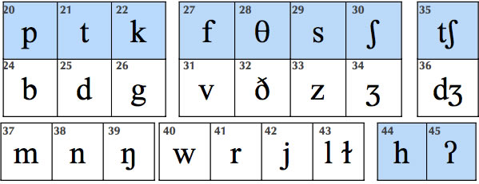
- English Vowels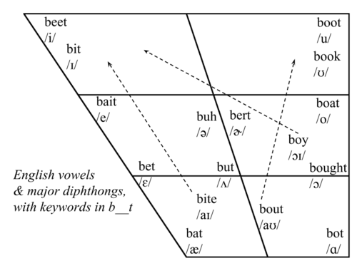
Vowel | Description | Example
 | forward vowel | as in beet
 | forward vowel | as in bit
 | diphthong | as in bait
 | forward vowel | as in bet
 | diphthong | as in bat
 | diphthong | as in by
 | diphthong | as in house
 | back vowel | as in boot
 | diphthong | as in abuse
 | back vowel | as in book
 | diphthong | as in boat
 | back vowel | as in awe
 | diphthong | as in boy
 | back vowel | as in father
 | central vowel, stressed | as in bud
 | central vowel, unstressed (schwa) | as in appeal
 | central vowel with r, stressed | as in burr
 | central vowel with r, unstressed (hooked schwa) | as in butter

- Good pronunciation requires good listening: The Echo Method

- Listen carefully to a good model. Good listening habits are the basis of good pronunciation. Practice active listening.
- Work with short phrases.

- PAUSE. Don’t jump in too soon.

- As you pause, listen to the “echo” in your head.

- Imitate the “echo” you hear; don’t automatically use the pronunciation you’re accustomed to.

- Get feedback; at first it may be uncomfortable, but it’s what helps
us improve and grow. Note facial expressions of your listener.
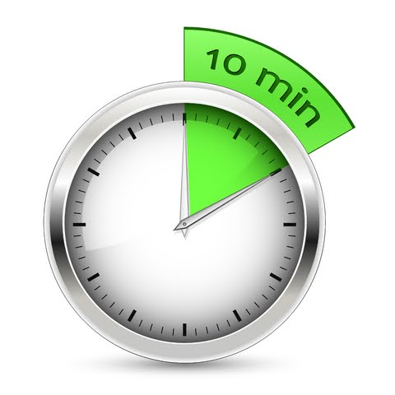

- Daily practice: listening, imitating, reading aloud.
10 MINUTES A DAY! One phrase at a time,
about 5-7 words: Listen-Echo-Repeat. Listen-Echo-Repeat.

- After you can repeat the phrase after the 1. Echo (Listen-Echo-Repeat) without thinking much, move on to 2. Listen-and-Repeat 跟著唸several times; then 3. Simultaneous 同步reading or reciting along with the audio.

- Mistakes are treasures – they show us how language works and how to adjust our teaching.

- Phrasing and intonation
Taiwanese tend to race to the finish when reading, with almost no pauses, making it difficult for listeners to understand. The reader will also not usually understand what they’re reading, and they will sound stressed and nervous. Conscious learning of where to pause can fix this!

A. Pause:
- After the complete subject
- Before “that” and other clauses
- At most punctuation marks
- Before conjunctions
- Before prepositions
- Parentheticals (e.g. Ted, unfortunately, couldn’t come.)

B. Three Basic Rules of Intonation:
1. Stress content words
(nouns, verbs, adjectives, some adverbs);
don’t stress function words
(articles, conjunctions, prepositions, pronouns,
helping verbs, “be” verbs, some adverbs).
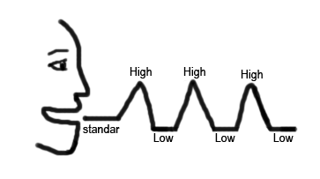
2. Stress new information; don’t stress old information.
3. Stress contrasted words; everything else is unstressed
(a low, flat tone).
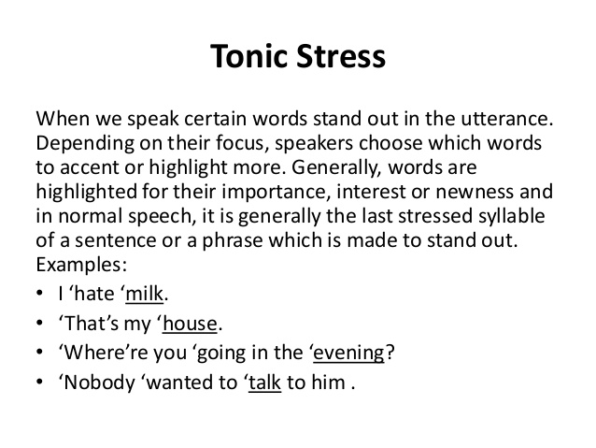

C. * Tonic Stress:
The last stressed syllable in every phrase or thought group gets
an especially high (or low) intonational stress. It’s marked with an *asterisk.

D. Continuation Rise ʅ
Taiwanese students tend to have a falling intonation
at the end of all phrases.
ʅ
But there should be a rise at the end of most phrases
that aren’t the end of a sentence.
The highest point is the tonic stress,
then it falls low, then there’s a gentle rise.

- Watch out for the pronunciations of these common words:
of [ʌv] or [əv], as [æz], because [bi 'kʌz], she [ʃi] (NOTㄒㄩ),
says [sɛz] (not [sez] or [seɪz]), said [sɛd] (not [sed] or [seɪd]), ask, asks, asked.

- Voicing affects vowel length
If the final sound of a syllable is voiced, the vowel that precedes it must be lengthened. Contrast the following: cap/cab [kæp]/[kæːb] lit/lid [lɪt]/[lɪːd] duck/dug [dʌk]/[dʌːg]
lap/lab; mop/mob; pup/pub; cop/cob; rope/robe; bit/bid; pat/pad; sit/Sid; set/said; mutt/mud
- Compound Noun Stress
In compound nouns, i.e. noun + noun expressions, only the stressed syllable of the modifying noun is stressed. Adjective + noun expressions with special meanings are stressed in this way too. These expressions are stressed as though they were one word.
Examples: convenience store, peanut butter, exercise bike, newspaper, girlfriend, boyfriend, bookshelf, computer desk, airplane, insurance salesman, car door; hot dog, greenhouse, blackboard

- Reading for pronunciation practice:

Parrot Story
By Shi Mingqi, Taoyuan
Audio: http://homepage.ntu.edu.tw/~karchung/CETPron2017/parrotstory.mp3
Mr. and Mrs. Huang, a couple in Taipei county who run a betel nut stand, had a pet parrot. You couldn’t help but love this parrot. He was a friend of the neighborhood children, and a group of students came to visit him every day after school to play with him. This very smart parrot knew how to talk – he would often call out “Mommy”, “Daddy”, “Hello”, and “Bye-bye”. When a child laughed or cried, the parrot would imitate the sound, sometimes crying even louder than the child. Every evening when the garbage truck came by, this very responsible parrot would begin to jump around wildly, urging his master to bring the bags of garbage to the truck.
The Huangs’ lives revolved around this parrot as though he were their own child, and he called them “Daddy” and “Mommy”. But one day misfortune came to the happy family – the parrot was stolen. Mrs. Huang was miserable to distraction. Every time she thought of the parrot, the tears would stream down her cheeks. During the day she would ride her motorcycle from pet shop to pet shop looking for the bird. She couldn’t sleep at night. After a few days without her beloved parrot, she asked to ride along with the garbage collectors in their truck when they did their route, hoping for a miracle.
The kidnapped parrot became very sad and depressed when he realized that his masters were nowhere to be found. He wouldn’t eat or drink. Some days later, the Taoyuan county police found and arrested the criminal ring responsible for the theft. They brought the parrot to a pet shop for temporary safekeeping. The pet shop owner said the parrot was very well-behaved, and he called her “Grandma”. But he wouldn’t touch the fruit and bird feed she brought him. She tried to force-feed him, but he still refused to accept the food.
When Mr. Huang received notice from the police that their parrot had been found, he and his wife immediately rushed over to the pet shop in Taoyuan to bring their beloved parrot home. To their dismay, they found that the parrot had lost a lot of weight, and his wings were injured. The Huangs’ hearts ached when they saw all the birdseed stuck to his neck, concrete proof that in their absence, he would rather die than accept food.
When he saw his masters arrive, the parrot, who was near death, flapped his wings excitedly in greeting, and called out loudly, “Hello, Master!” Mr. Huang was deeply moved. Heaven had not deserted him, his parrot hadn’t starved to death, nor had he been sold. Having gotten their dear pet back, Mr. and Mrs. Huang hugged each other tightly and cried tears of joy. They kept repeating, “We are happier than if we’d won first prize in the lottery.”
China Times, April 18, 2005

- TV Series: The Big Bang Theory
Go over the script carefully, one scene at a time.
Look up all the words, phrases and cultural allusions you're not sure of.
Make sure each line makes sense! If it doesn't, Google it!
Next, go back and do Echo practice.
Here is a Chrome extension called “Stream Series” that you can use
to watch TV shows online relatively safely without ads:
https://chrome.google.com/webstore/detail/stream-series/cdagmkghogpcneieahjlcbnfipgeafch?hl=en
Do a search on Stream Series for The Big Bang Theory, then choose Episode 7 of Season 3;
it's called “The Guitarist Amplification”. Here is the transcript in Word format:
http://homepage.ntu.edu.tw/~karchung/BigBangTheoryS3E7.doc
Online transcript:
https://bigbangtrans.wordpress.com/series-3-episode-07-the-guitarist-amplification/
Echo file:
https://ceiba.ntu.edu.tw/course/44b113/bulletin/312885_bigbangtheoryscene1.mp3

- Transcript for The Big Bang Theory: Series 03 Episode 07 – The Guitarist Amplification
Scene One: The apartment.
Penny: Wow, Sheldon, I cannot believe you made up your own game.
Sheldon: Oh, Research Lab is more than a game. It’s like the slogan says, the physics is theoretical, but the fun is real.
Leonard: We must not be playing it right.
Penny: All right, five. One, two, three, four, five. Oh, wow, look at that, my Department of Defense research grant is renewed.
Sheldon: Oh! Great roll! Now you can demolish your Soviet-style cyclotron and build the large Hadron Collider.
Penny: Yay.
Sheldon: You’re a natural at this, Penny. And as the first beta testers, you two’ll have quite the edge when we play with Wolowitz and Koothrappali on Sunday.
Leonard: Oh, gee, Sheldon, I don’t think we can play on Sunday.
Sheldon: Why not?
Leonard: Because…of the reasons that Penny will now tell you. Penny?
Penny: Actually, I have to pick up my friend Justin from the airport.
Leonard: There you go, she has to pick up her friend Justin at the airport. And I can’t play ’cause I’m going with her, right?
Penny: Um, yeah, if you want. I mean, there may not be room. He’s got a lot of stuff, like guitars and amplifiers.
Leonard: Wait. What are you talking about?
Penny: My friend, Justin.
Sheldon: Pay attention, Leonard. That’s why she can’t play on Sunday.
Leonard: Who is this Justin?
Sheldon: Your turn, Leonard.
Penny: I told you about him.
Leonard: No, you didn’t.
Sheldon: Roll the dice, Leonard.
Penny: Yeah, my friend from Omaha, plays the guitar. Anyway, he’s coming to L.A. looking for some session work, so I told him he could just crash on my couch for a few weeks.
Sheldon: Come on, Leonard, if you roll a six, Penny dies horribly in a nuclear meltdown. See what I mean when I say the fun is real?
Leonard: Hang on. Some guy is going to be sleeping on your couch?
Penny: He’s not some guy. He’s my friend.
Leonard: So by friend, do you mean friend friend, gay friend, or ex-boyfriend-who-you’re-now-platonic-with-but-still-might-have-a-thing-for-you friend?
Penny: Well, he’s definitely not gay.
Leonard: Oh, a definitely not gay musician sleeping on my girlfriend’s couch. Yippee.
Penny: Okay, we went out a little bit, a long time ago, but we were never like “going out”.
Leonard: Okay, not to be pedantic, but the last I checked, “went out” was in fact the past tense of “going out”, which I think we all know is a popular euphemism for “saw each other naked”.
Sheldon: I’ll just roll for you.
Penny: Do you have a problem with Justin staying with me?
Leonard: What was your first clue?
Sheldon: Uh-oh! Industrial accident!
Penny: You know what? Don’t talk to me like I’m an idiot.
Leonard: I’m not talking to you like you’re an idiot! I’m saying the whole idea is idiotic!
Sheldon: You accidentally stare at a helium-argon laser. Lose one turn and a retina.
Penny: How is that not talking to me like I’m an idiot? It’s my friend, it’s my couch, and it’s my freakin’ life!
Sheldon: It’s also your roll.
Leonard: You know what? It is your life. If you want to have some stupid guitarist stay on your couch, then fine. Why don’t you just rent some bunk beds and invite The Black Eyed Peas?
Penny: Hey, if I want to invite the entire lineup of Lollapalooza to sleep in my apartment, I will, and it’s none of your business!
Leonard: Are you listening to yourself? Do you know how childish you sound right now?
Penny: Oh, now I’m a child? Well, at least I’m not an idiot anymore!
Leonard: The two aren’t mutually exclusive!
Penny: Oh, you are such a… (Sheldon has placed ice in the blender and turned it on) What the hell is he doing?
Leonard: He’s drowning us out. He doesn’t like fighting.
Penny: Sheldon, just stop, look, the fight is over. Oh, and FYI, you never even heard of The Black Eyed Peas until you met me!
Leonard: I heard of ’em. Didn’t know they were a band. Sheldon, she’s gone. You can turn off the blender.
Sheldon: Has your relationship reached its inevitable ugly end?
Leonard: No, we just had a little spat.
Sheldon: Look on the bright side. As the result of Penny’s forfeit, you have become the world’s first winner of Research Lab. Would you like a commemorative snow cone?

Additional resources here: http://homepage.ntu.edu.tw/~karchung/30/30Tricks.htm

Have you done your 10 minutes of Echo practice today?
https://www.babbel.com/magazine/static/img/social-sharing-image/en/LangLearningBasic_Illus_FB1200.png

http://www.anenglishaccent.com/Images/consonants.jpg
http://68.media.tumblr.com/fec1095aa634aa92868bd49a4cfc736e/tumblr_inline_mulkb0Rnc91rplshr.png
http://cmed.faculty.ku.edu/ipafolder/vowels.html

